**The Dataset**

Available syllabi in PDF format from Spring 2022 - Fall 2024, excluding summers (6 semesters, 3 falls).

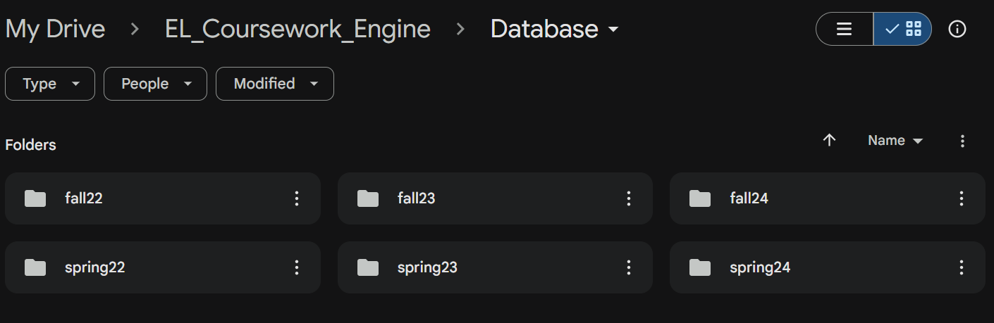

Descriptive insights:

* From Tepper’s online catalogs ([BUS](http://coursecatalog.web.cmu.edu/schools-colleges/tepper/undergraduatebusinessadministrationprogram/courses/), [ECO](http://coursecatalog.web.cmu.edu/schools-colleges/tepper/undergraduateeconomicsprogram/courses/)): 145 courses. Course types include: 'Fall and Spring', 'Fall', 'Intermittent', 'All Semesters', 'Spring'
* Dataset of courses with a syllabus: 90 courses
  + No duplicates but recorded repeated submissions over the semester

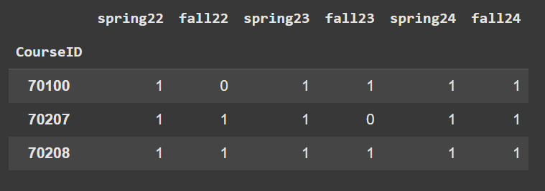

* + Added 4 courses that weren’t on the catalog

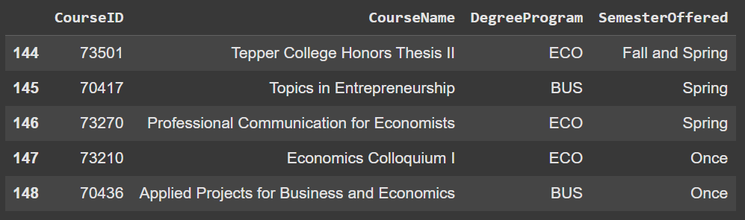

* + Per course, counted total semesters with a syllabus submission & calculate a “consistency” percentage

Final table:

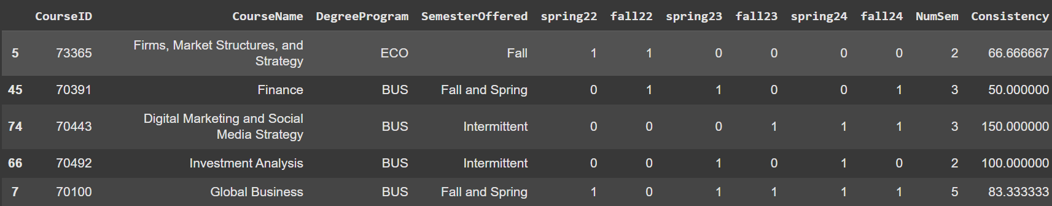

Final stats:

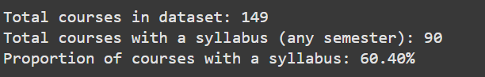

**Syllabi Submission Trends**

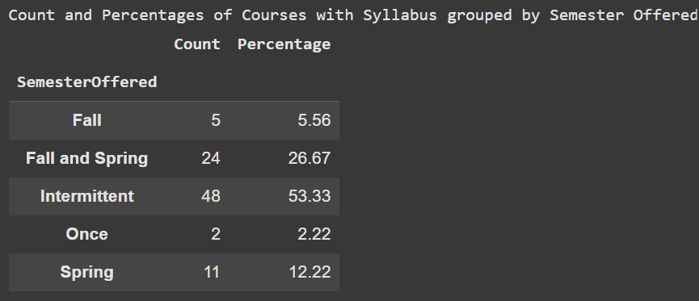

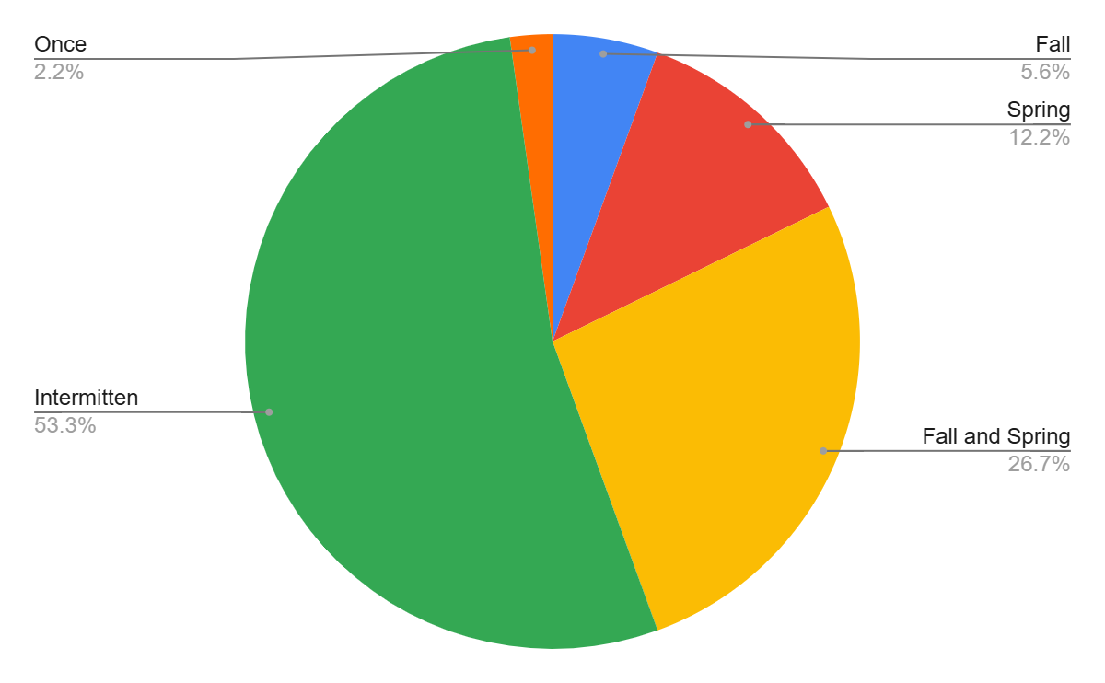

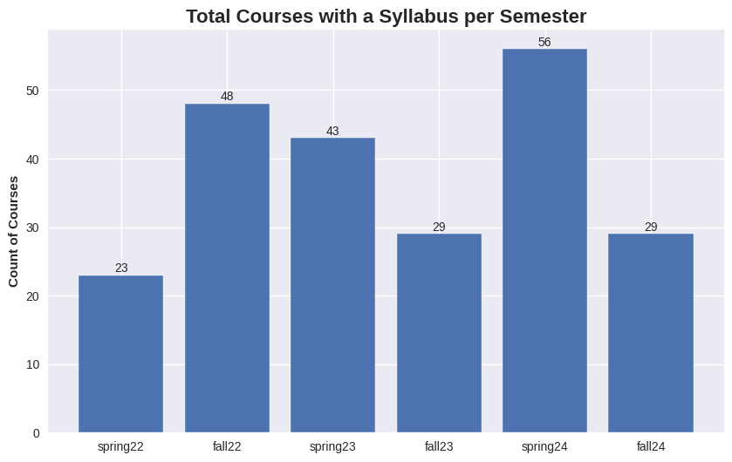

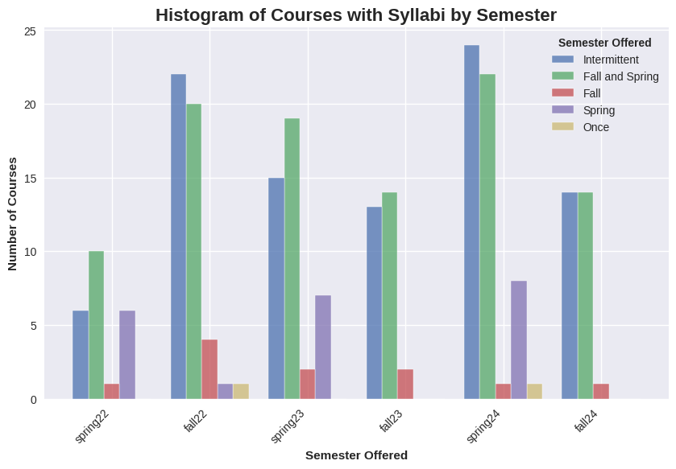

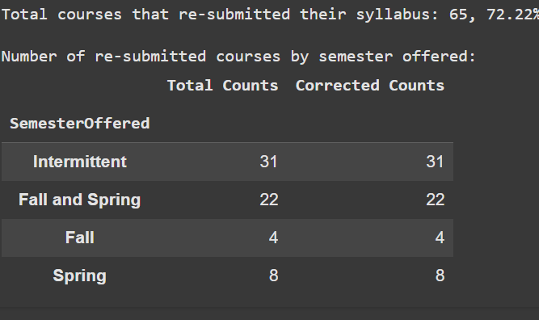

|  | Total Count | Resubmits |  |
| --- | --- | --- | --- |
| Fall | 5 | 4 | 80.00% |
| Spring | 11 | 8 | 72.73% |
| Fall and Spring | 24 | 22 | 91.67% |
| Intermitten | 48 | 31 | 64.58% |

**Experiential Learning Insights**

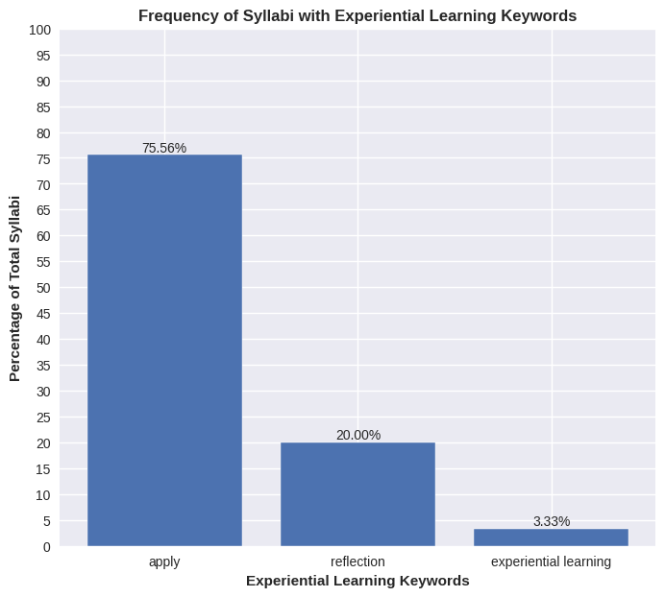

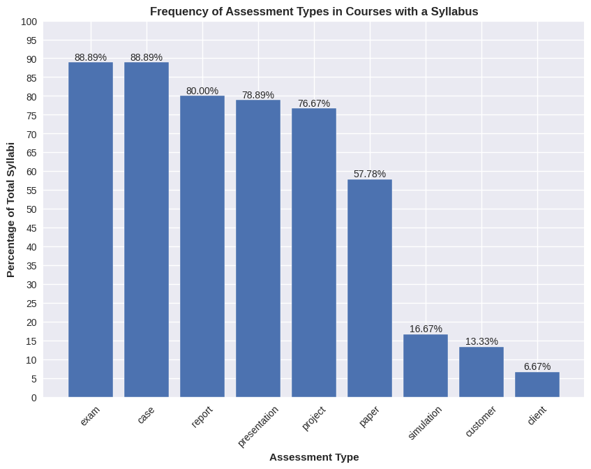

**Insights after reviewing select courses:**

* Notable courses:
  + 70-447 - Client consulting project, Strategic Management of the Enterprise
    - A Capstone project with a real client. Missing reflection piece.
  + 73-497 - Economics senior project
    - Capstone project with a real client. There is a feedback loop and a peer review, but not sure about an experiential learning reflection.
  + 70-304 - BLE III
    - The BLE series have a very in-depth reflection schema, but BLE III mentions presenting at Leadership TED Talk but not sure if this is a real event at Tepper
  + 70-415 - Intro to Entrepreneurship
    - Strong reflection schema, separating goals for application and knowledge. Students compete in a sales challenge with actual investment from the instructor.
  + 70-246 - Innovation & The Entrepreneurial Mindset
    - Interview with a real entrepreneur that the professor invites to class (they learn about the concepts, create questions with guidance from professors - lacking reflection). Called the final project a “Capstone” but no real client
* General trends:
  + No real client / authentic stake
  + Reflection pieces are often on specific reading assignments and peer reviews. Rarely were there reflection on the experiential learning projects or components.
  + Unclear how peer reviews and self-assessments after project are conducted
    - Do they allow students to think beyond the project and the specific skills they applied?

***Courses that mention a client:***

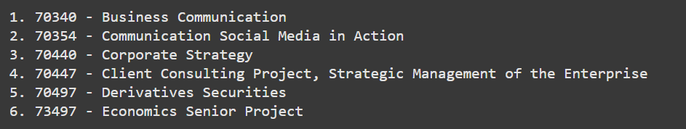

70-340 - There is an assignment called “Team Consulting Project” where students draft and present a consulting report. The word client was used but there is no indication in the syllabus of a real client (figure 1.1). The “reflection” piece was more “peer-review” than reflections (figure 1.2). Moreover, there seems to be a self-and group assessment after the project that seems to be more to ensure equal work distribution (figure 1.3).

Fig 1.1.

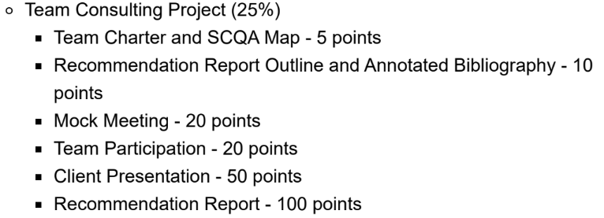

Fig. 1.2

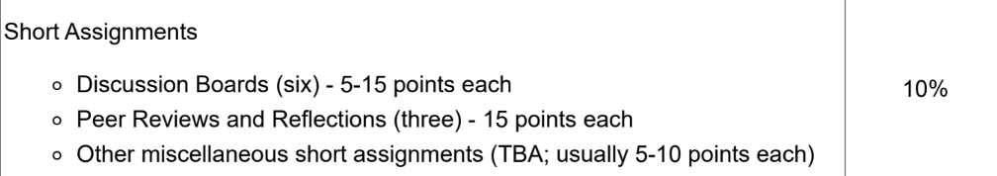

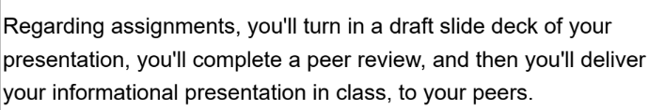

Fig. 1.3

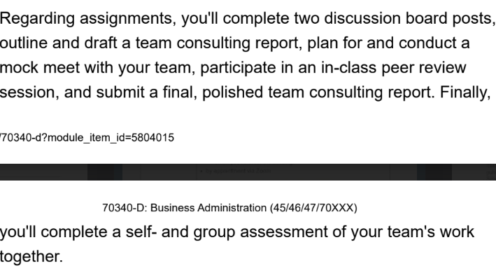

70-354 - No real client—the word was just mentioned to describe outcomes. The project component seems interesting: Students choose organizations, conduct research, then pitch ideas for a blog, social media account, and podcast. The is a “launch” associated with each type of media, but unsure if they will actually go live. After each launch, students provide and receive feedback from one another.

70-440 (Qatar campus) - No real client for group project (figure 2.1). Missing reflection piece.

Fig 2.1

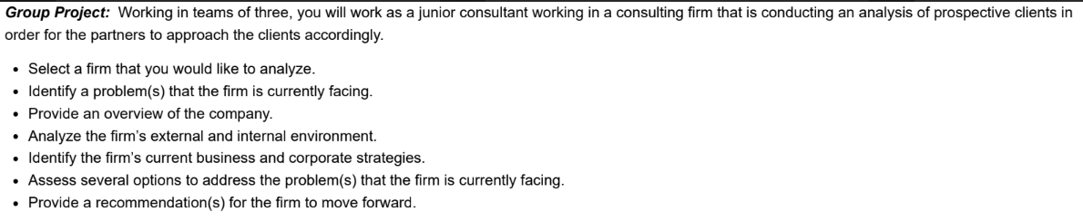

70-447 - A Capstone project with a real client. Missing reflection piece.

70-497 - No real client. The students role play the clients for one another. Missing reflection piece.

73-497 - Capstone project with a real client. There is a feedback loop and a peer review, but not sure about an experiential learning reflection.

***Courses that mention experiential learning:***

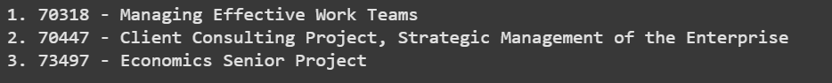

The last two are repeated above.

70-318 - Despite not having a real client, this class has a very in-depth reflection schema (fig 3.1). Students work in teams for activities throughout the course and reflects on their experience after being presented with certain challenges. They also do case analyses.

Fig. 3.1

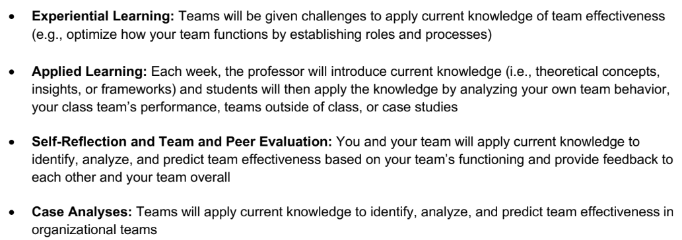

***Courses that mention a project AND reflection:*** 14

70-100 - There is a case analysis project and online simulation but no real client. Reflection questions were separated from projects - not tied to the experiential learning experience.

70-104 - No authentic stake. Did not provide details on the final project. There are reflection entries but not sure if tied to experiential learning experience.

70-204 - Same as above (in a series of classes - BLE)

70-246 - Interview with a real entrepreneur that the professor invites to class (they learn about the concepts, create questions with guidance from professors - lacking reflection). Called the final project a “Capstone” but no real client

70-304 - Leadership TED Talk? Otherwise, same as the BLEs above

70-341 - same as 70-318

70-415 - Strong reflections, separating goals for application and knowledge. Students compete in a sales challenge with actual investment from the instructor.

70-416 (Qatar) - Teams shape an idea into an entrepreneurial plan and present to the wider CMUQ community to “seek partners” and "funders.”

70-452 - no actual projects, just homeworks

70-483 & 70-485 - nothing of note

70-499: Internship over the summer that provides academic credits. Must submit reflection entries weekly.

73-210: brings a few guest speakers to class and students must prepare questions for.

***Remaining courses that mention reflection***:

70-321: No authentic stakes but the students get to do a pre and post prep for their in-class negotiations with one another